EXPERIMENT – 4
DETECT OUTLIERS IN A GIVEN DATASET
Aim:
To detect outliers in a given dataset
Procedure:
- Import numpy and create an array with random integers
- Create a function for outlier
- Then plot it using seaborn with displot and distplot

Program:
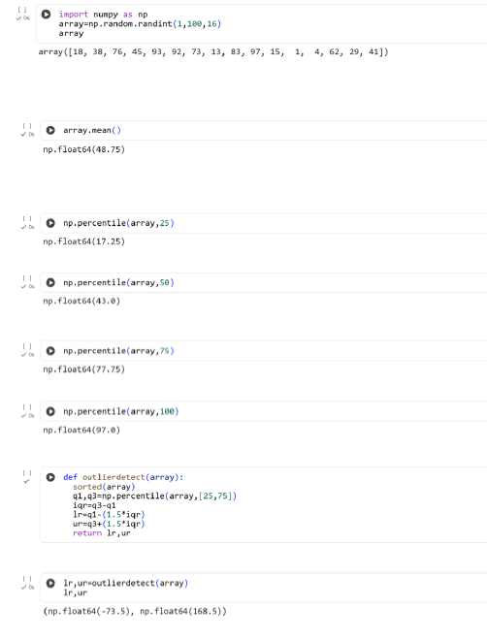

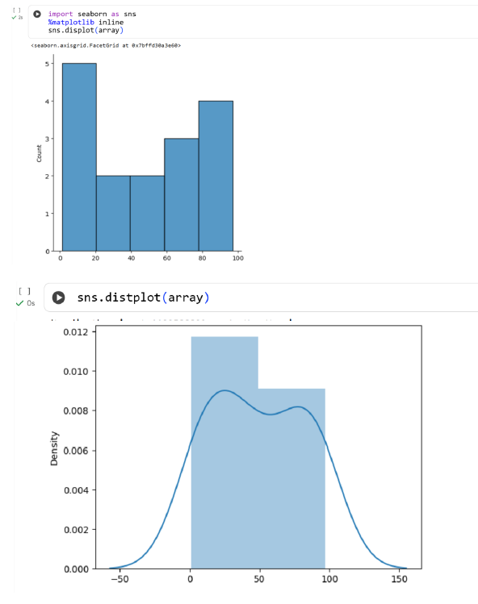
Result:
Thus the python program to detect outliers in a given dataset is executed and output verified successfully

